PRACTICAL – 1
Problem Definition: Initiate the semester-long StudentHub portal by identifying the problem scope, user roles, key modules, navigation flow, and minimum 10 pages. Create a sitemap, low-fidelity wireframe, project folder structure, README file, and GitHub repository.
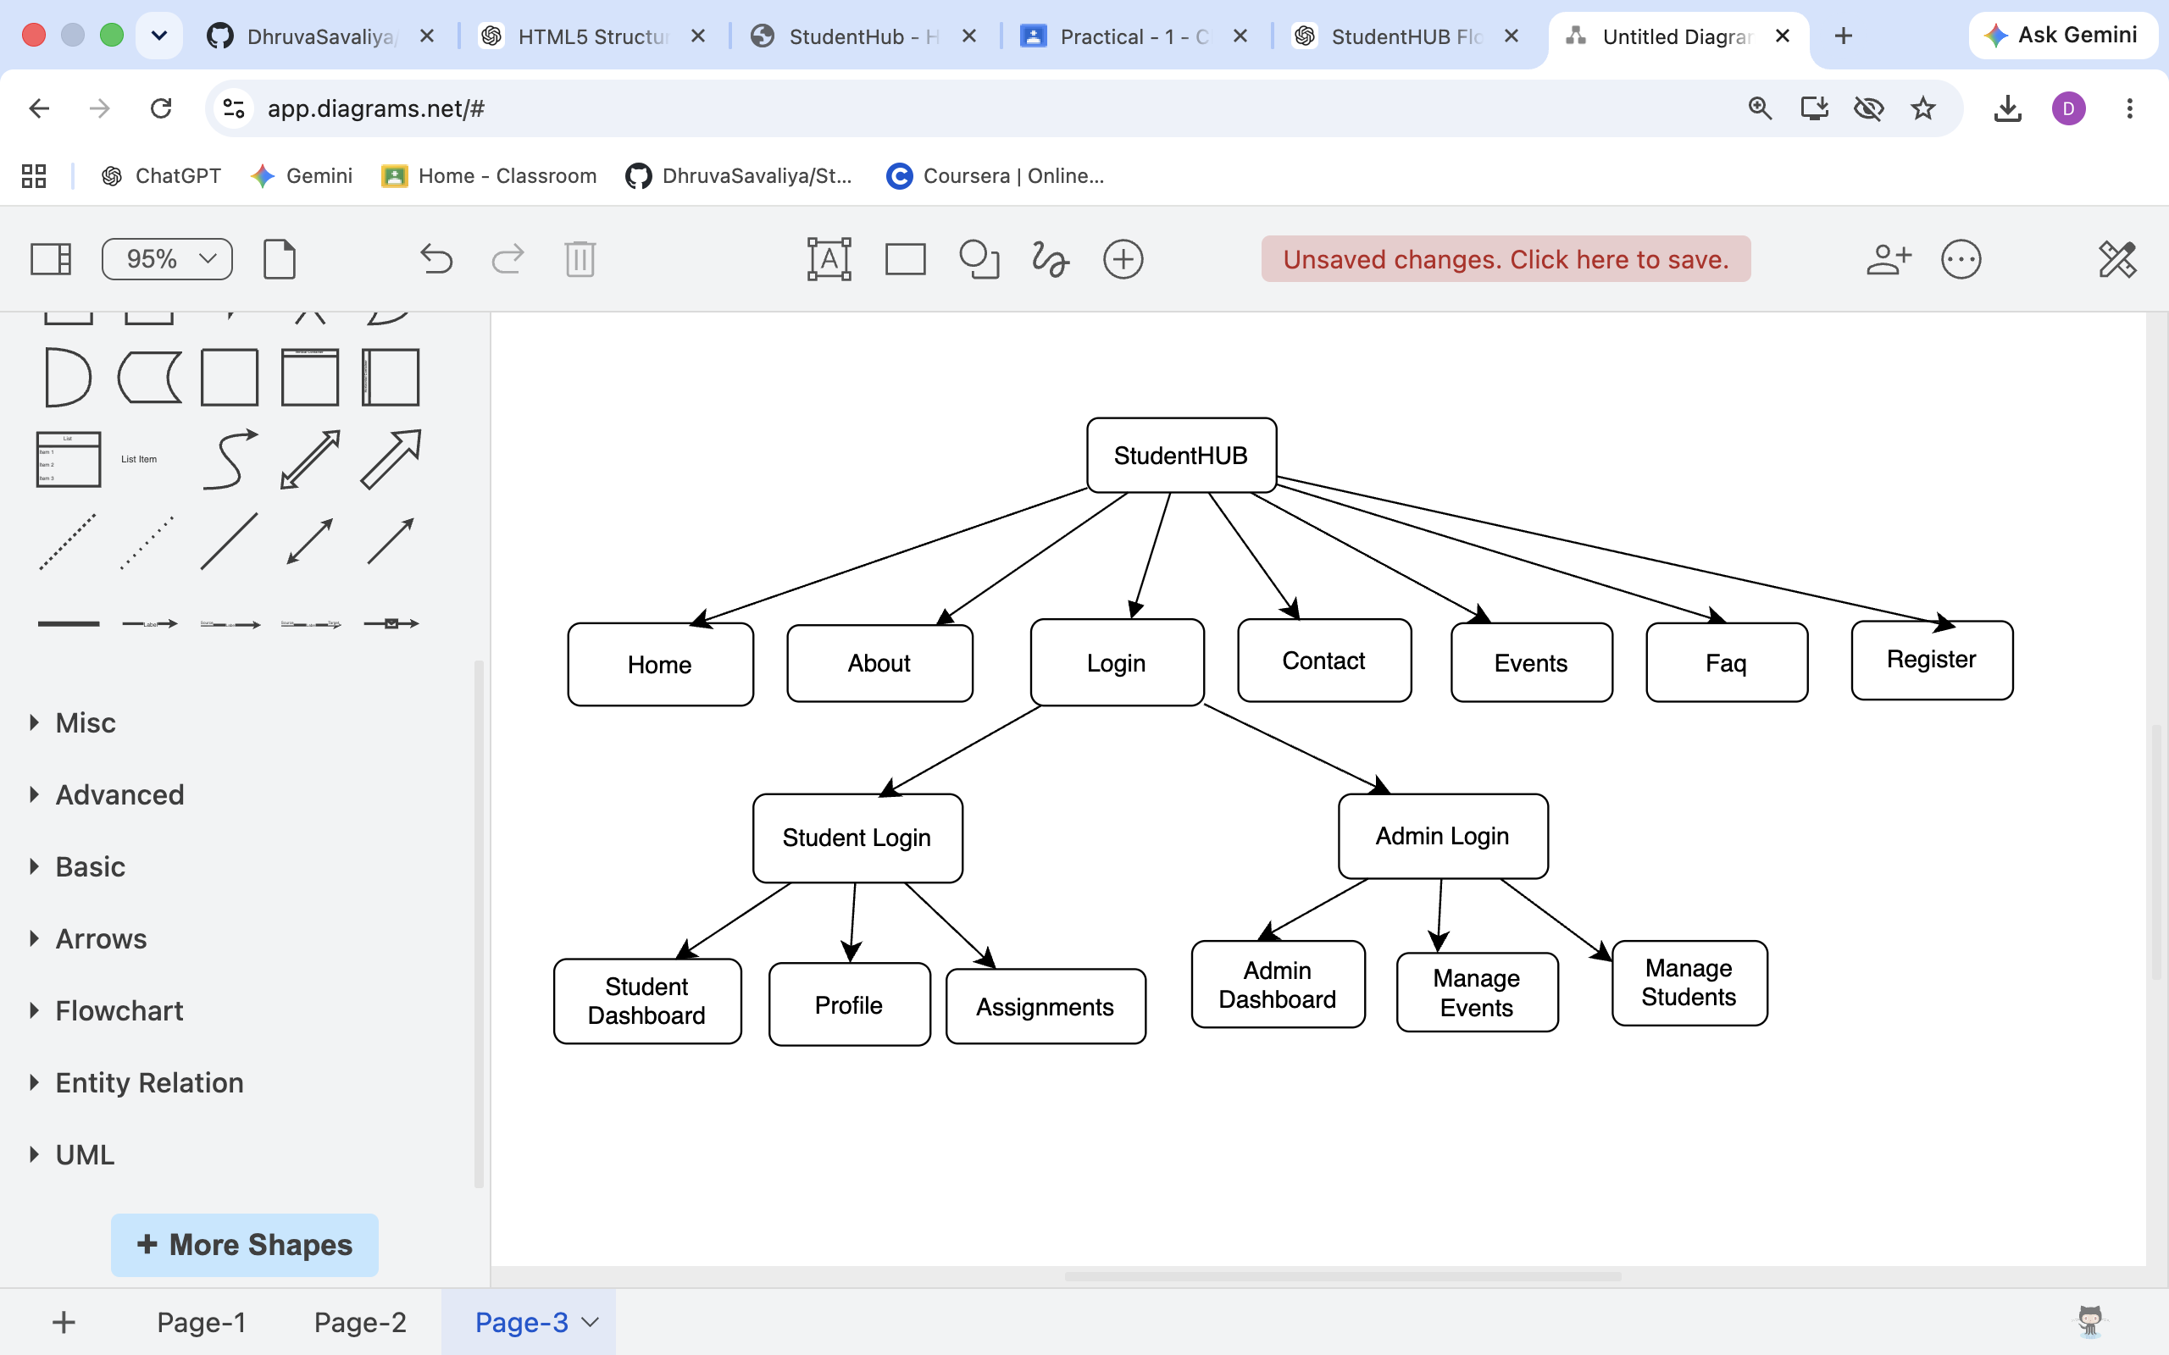
StudentHub Sitemap:

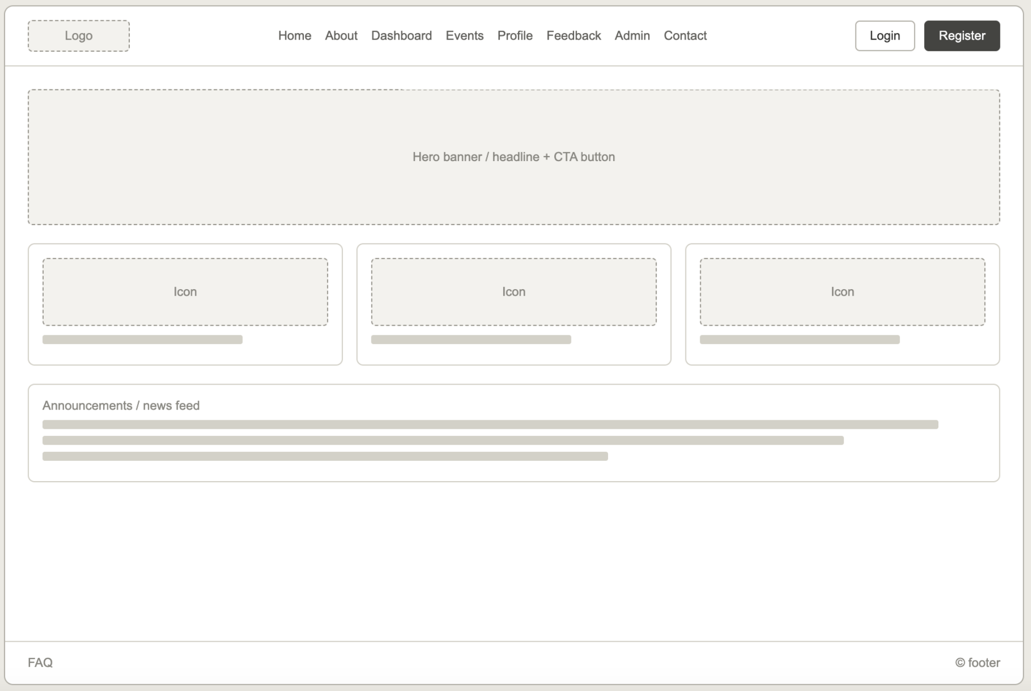
Home-Wireframe:

Admin-wireframe:


Profile-wireframe :
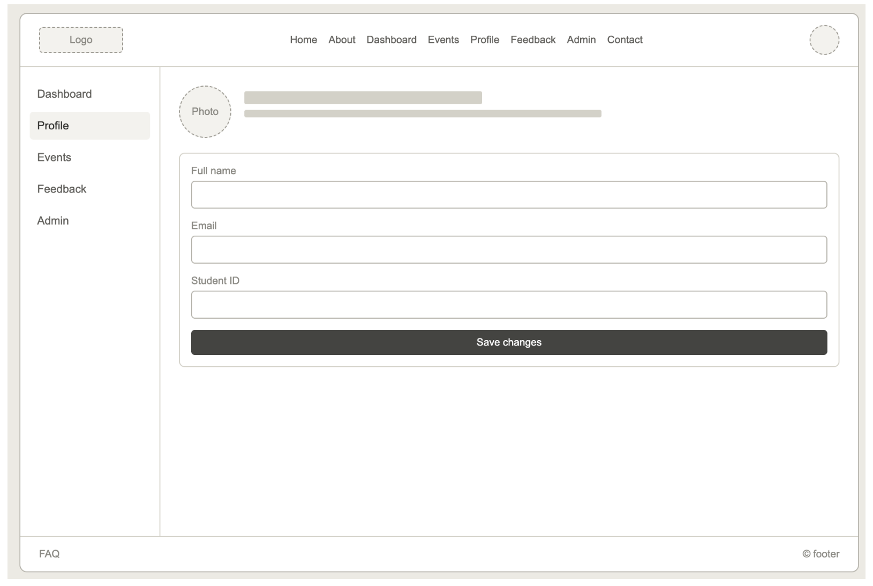

Student Dashboard-wireframe:
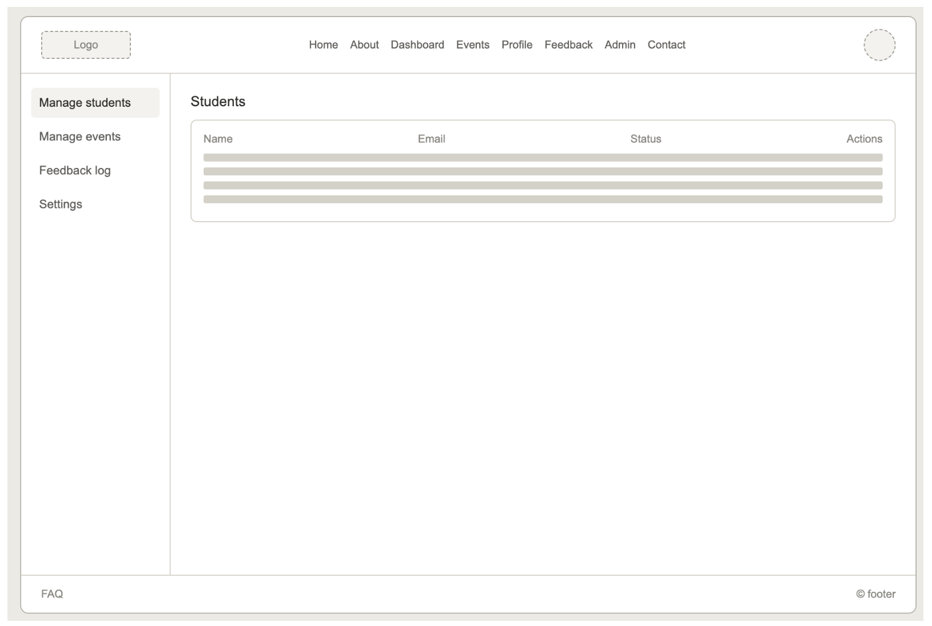
README.md
Project Overview
StudentHub is a web-based student portal developed as a semester project. The portal provides a central platform where students can access academic information such as assignments, attendance, timetables, events, and personal profiles. It also includes an admin module to manage students, faculty, courses, events, and reports.

Objectives
- Provide a centralized student portal.
- Improve communication between students and the institution.
- Simplify access to academic resources.
- Enable administrators to manage portal data efficiently.
- Create a responsive and user-friendly interface using HTML5.

Features
Student Module
- Student Registration
- Student Login
- Dashboard
- Profile Management
- Attendance
- Timetable
- Assignments
- Events
- Feedback
- Logout
Admin Module
- Admin Login
- Admin Dashboard
- Manage Students
- Manage Faculty
- Manage Courses
- Manage Events
- View Feedback
- Generate Reports
- Logout

Technologies Used
- HTML5
- CSS3
- JavaScript
- Visual Studio Code
- Git & GitHub
- draw.io (Sitemap & Diagrams)

GitHub Repository:

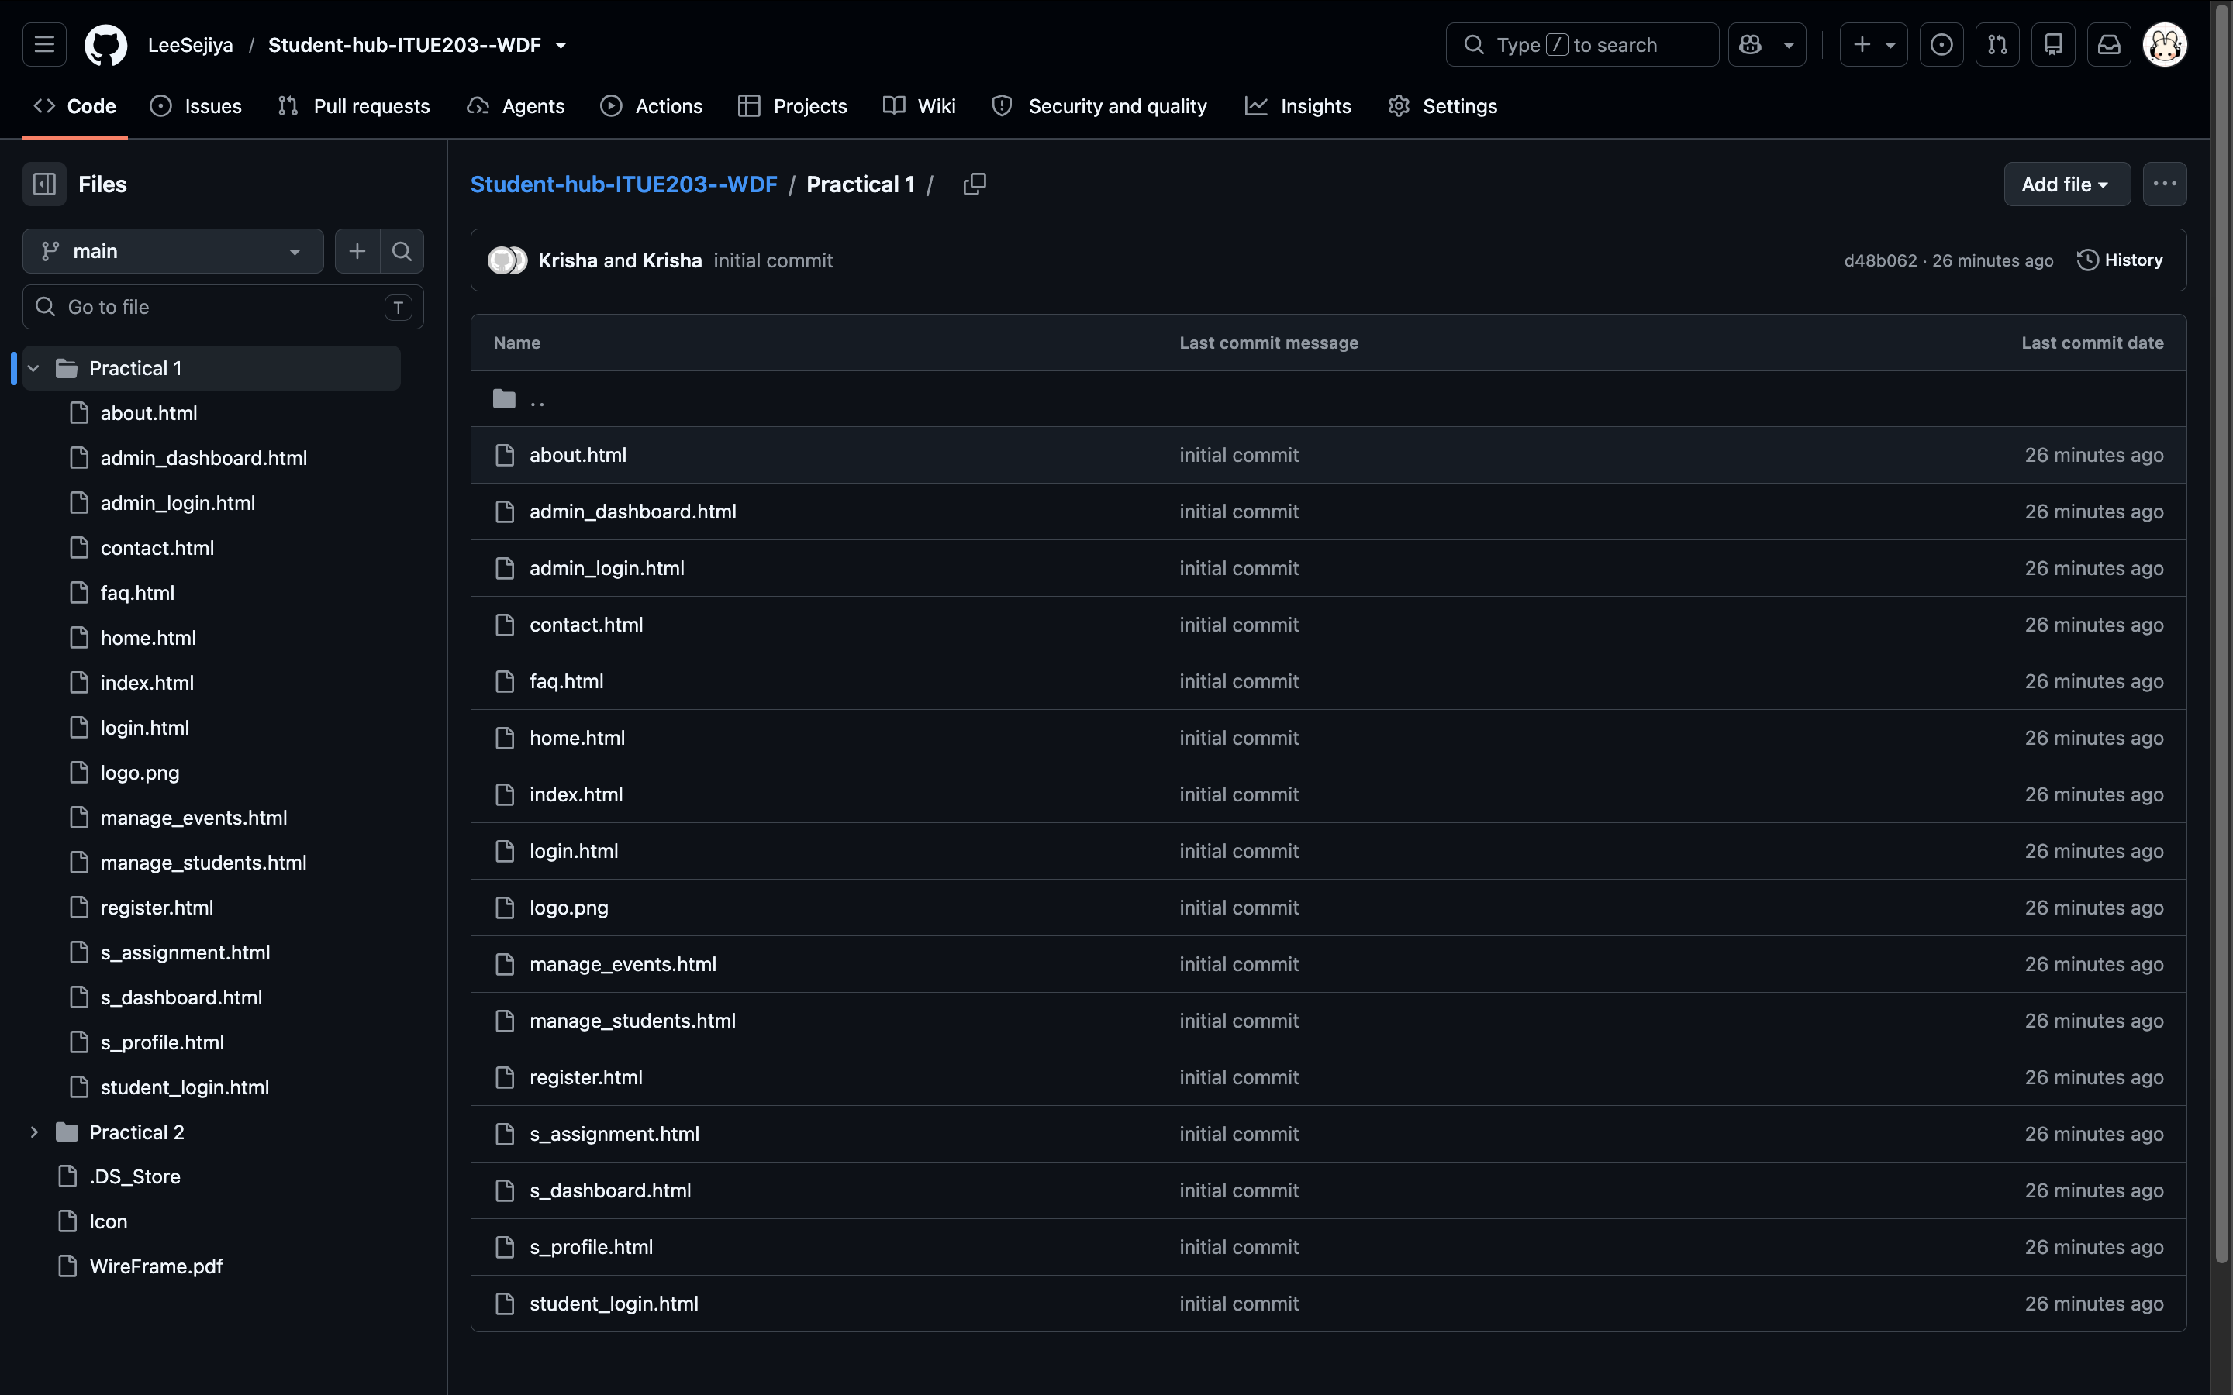
Link: https://github.com/LeeSejiya/Student-hub-ITUE203--WDF

Question & Answer:

- What is URL and parts of URL?
Ans. A URL (Uniform Resource Locator) is the address of a web page or resource on the internet.
Its main parts are: Protocol (https://), Domain Name (www.example.com), Path (/page), Query Parameters (?id=10), and Fragment (#section).

2. How does HTML file processed in web browser?
Ans. The browser reads the HTML file and creates the page structure (DOM).
It then loads CSS for styling and JavaScript for interactivity before displaying the webpage to the user.

3. How will page navigation flow managed among all HTML pages?
Ans. Navigation is managed using hyperlinks (<a> tags) that connect one HTML page to another.
A common navigation bar is added on all pages for easy and consistent movement throughout the website.

4. How will GitHub commits be maintained after each practical?
Ans. After completing each practical, the updated files are committed with a clear and meaningful commit message. The commits are then pushed to GitHub to maintain a version history and track project progress.

Conclusion / Learning Outcome:

In this practical, I successfully initiated the StudentHub Portal project by defining the problem scope, identifying user roles, planning the key modules, and designing the navigation flow. I created a sitemap, low-fidelity wireframe, project folder structure, README file, and GitHub repository to organize the project effectively. This practical helped me understand the basics of web project planning, HTML page organization, GitHub version control, and the importance of proper project documentation before starting development.

